MODEL-2 CATTLE BREED CLASSIFIER
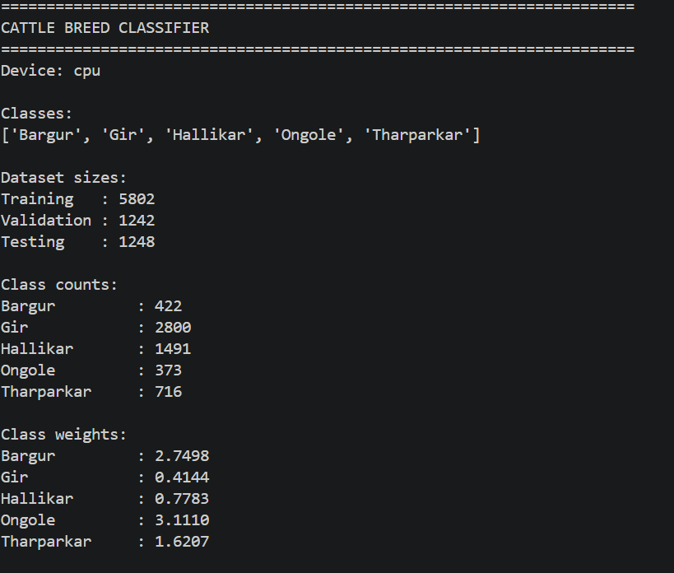
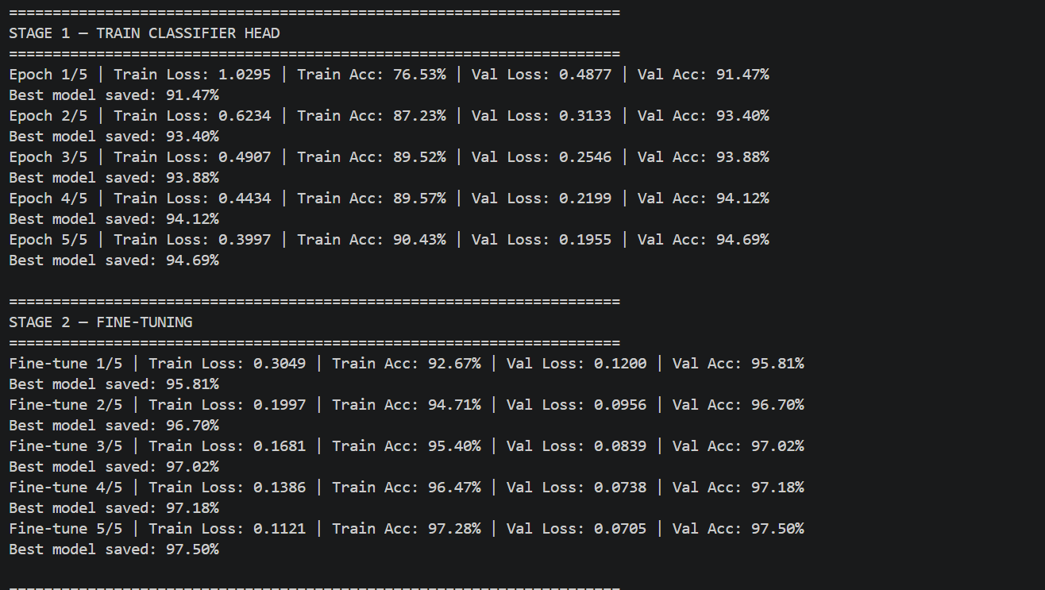
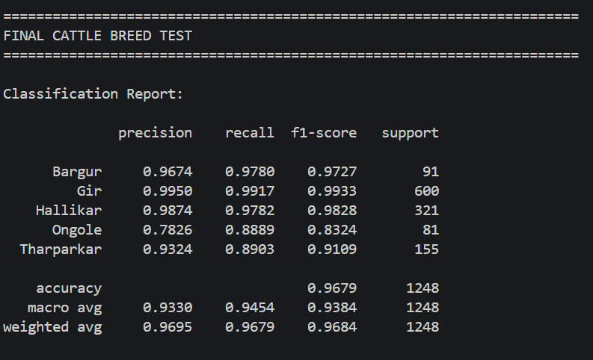
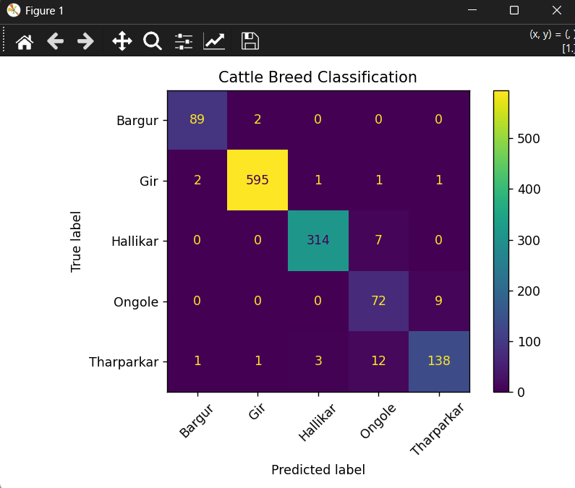
model achieved:
- Test accuracy: 96.79%
- Macro F1: 93.84%
- Weighted F1: 96.84%

